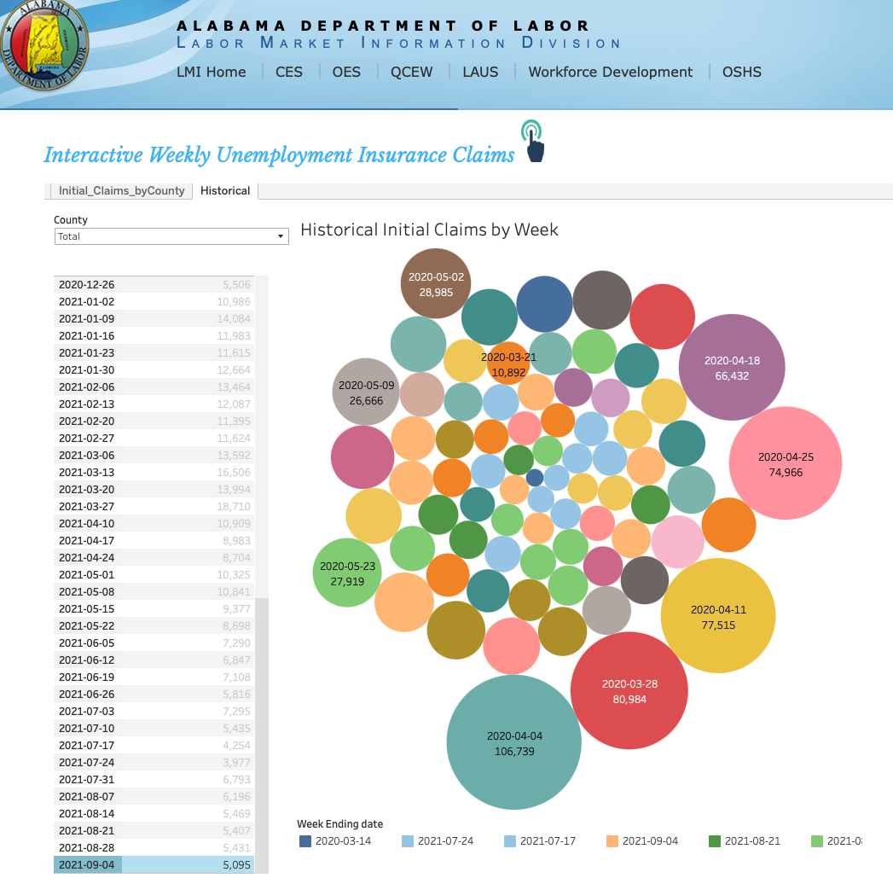

This bubble chart represents historical initial unemployment claims by week for the Alabama Department of Labor. The visualization attempts to show trends over time, but it has significant design and interpretative flaws that impact its effectiveness.

* **Ugly Criteria — A figure that has aesthetic problems but otherwise is clear and informative**:

The random placement of circles makes it hard to follow any chronological pattern. Unlike a line chart or bar chart, which naturally guide the viewer through a timeline, this arrangement forces the reader to search for key data points.

The color choices seem random and do not represent a clear trend. Some circles share similar colors but don’t seem to correspond to meaningful groupings (such as months or years).

Some smaller circles are nearly invisible behind larger ones, making it difficult to interpret all the data points.

* **Bad Criteria — A figure that has problems related to perception; it may be unclear, confusing, overly complicated, or deceiving:**

Since this is historical data, a time-series format (like a line chart or bar chart) would be much clearer. Right now, it is impossible to easily track trends over time.

The size of the bubbles is meant to represent claim volume, but Area-based encoding is hard to compare accurately.

The visual differences in bubble size don’t precisely match the numerical values, making it hard to gauge the actual differences between data points.

The color legend at the bottom does not explain what the colors represent (weeks? categories? trends?).

* **Wrong Criteria — A figure that has problems related to mathematics; it is objectively incorrect:**

The numerical values themselves appear to be accurate based on the unemployment data.

However, some smaller values might be hidden behind larger bubbles, reducing visibility.